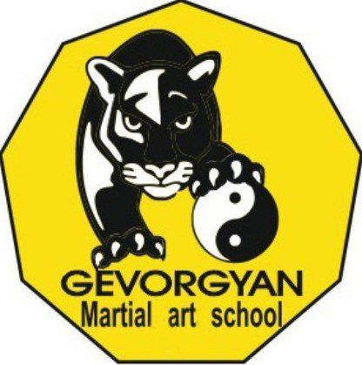

Training course

PATH OF PEACEFUL WARRIOR

08-14 September
Aghveran, Armenia

A. | Name Surname (as written in passport)
B. | Date of birth
C. | Sex |  | M F
D. | Nationality
E. | Education
F. | Position (in the organization Participating in the project)
G. |  | Please briefly describe your organization/group
- Contact Information of the Organization
Name:
Address:
Tel:
E-mail:
Web Site:
- Field of activities of the organization and your role in the organization

H. | What is your motivation to participate in the Training Course?
I. | Have you ever practices any martial arts or sports? Please specify what and for how long have you practiced?

J. | Describe your strengths and possible contribution that are relevant for this project implementation
K. | What are the program blocks in the draft program that you are most interested in and why?
L. | Briefly present yourself, your hobbies and interests.
M. | Special need if any (traumas, physical limitations, vegetarian, allergies, etc.)

The questionnaire should be sent to Gevorgyan.school@gmail.com email address
before the 5th of August, 2013

