We are looking for participants for the following innovative and exciting European Youth in Action 4.3 training course:

‘LEAD II’
A learning and development journey on leadership….

LEAD II is a training course that will explore leadership development with a special focus on diversity.

To be held in the South of Ireland from Saturday the 21st of June to Saturday the 28th of June 2014
(21st Arrival Day – 28th Departure Day)

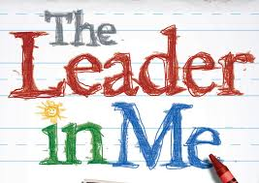

An initiative of Eolas Soileir (Ireland) & ALP - activating leadership potential (Austria) & funded through the European Youth in Action Programme

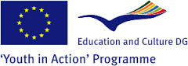
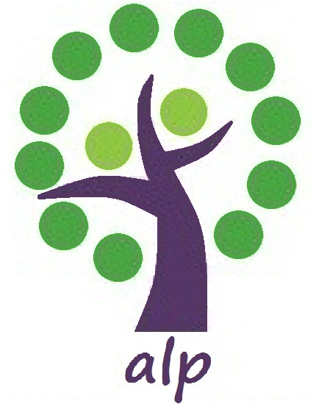

We are looking for youth workers, educators, peer educators, activists, community development workers & those who work or are connected with young people both in a professional and voluntary capacity.

Objectives of this training:

The aim of the training course is to provide leadership skills for today’s diverse world. We will be asking participants:
• To reflect on their personal leadership style, values, attitudes and skills in relation to leading in a diverse world.
• To gain a better understanding of working with gender and how to include people with different cultural backgrounds in your team.
• To exchange with other participants the challenges arising from diversity in your own environment and to build a network of exchange.
• To benefit from new knowledge and ideas on how to be more inclusive in their leadership role.
• To return home with new knowledge and ideas on how to be more inclusive in their leadership role with young people

*You will learn more about the funding possibilities of the Erasmus + programme and a chance to network with European partners.

*Our approach is creative, non-formal & participative.

We will have a productive and enjoyable week in a dynamic environment.
If you are interested in becoming a participant on this training please complete the application form below asap or before the 22nd of March 2014.
Travel arrangements (as per Youth in Action Programme criteria):

- Participation fees: 50 Euros – to be deducted from your travel refund.
- Board and lodging: fully covered
- Travel: 70% travel reimbursement
- 18 participants - 6 from Ireland, 4 from Austria, 2 each from Estonia, Italy, Denmark & Romania
- The training will take place in Clonmines (Wellington Bridge), Co.Wexford, Ireland, a beautiful rural location situated near the sea.
- Only apply if you are excited, interested and willing to work hard at the training. You will be challenged to take risks and go deep into issues.
- Please see below for programme and information about venue, trainers etc.

When deciding to come on this training please bear in mind these
important Points for all partners & participants:
- Training will take place in a rural location there is no shop, pub or amenities within walking distance of venue. It is located in the south of Ireland – Clonmines (near Wellington Bridge), Co. Wexford.
- Accommodation will be split between venue and nearby rented house. All participants will be accommodated in shared bedrooms.
- Food will be cooked for us, but we all share in the clean up after every meal.
- There is NO internet at either house or venue, so please come with your own mobile internet if you require it for the duration of the training.
- Arrival day Saturday 21st of June – the venue is approx. 3 hours bus journey from Dublin Airport. On Saturday there is only one direct bus that brings you to Wellington Bridge, which is 5km from the venue. The bus to Wellington Bridge leaves at 17.00 from Dublin Airport Coach Park and at 18.00 from O’Connell St (outside the Gresham Hotel), which is the main street in Dublin. All pax must travel by this bus as we will organise a pick up from Wellington Bridge when this bus arrives. This means that all pax must arrive in Dublin airport at the very latest 16.00 (which will leave you time to depart your flight, clear passport control, collect your bag and walk the 10 mins to the coach park). If you cannot make a flight that brings you into Dublin by this time, then I suggest you travel the day before and stay in Dublin Friday night. I can send suggestions of cheap accommodation in Dublin, which you must pay for yourself. Please only fly to DUBLIN airport, we cannot assist flights to any other airport.
- Departure day Saturday 28th of June – There is only one bus from Wellington Bridge, it leaves at 07.30 on Saturday morning and arrives at Dublin airport at 11.00.
- I am giving you this information to help you book your flights. The maximum travel budget granted for partners is around 500 euro per person for return travel tickets. Please allow 28 euro for return bus ticket to Wellington Bridge in Wexford. We will refund 70% of travel within these limits at the end of the training. Please keep all original travel receipts for refund (bus, train plane).
- Please only attend if you are a motivated participant and MUST be willing to dive head-in and participate FULLY in the training.
- Where possible please ensure a gender balance when selecting participants.
- All participants must be 18 years of age or over.
- All participants are responsible for their own health and travel insurance.
- All participants must be able to communication and work in English.
- See programme below for more information.
- Email Deirdre at dquinlan6@gmail.com for more information.

The main trainers on this TC are Deirdre Quinlan, Irene Rojnik & Jack Talbot.
Deirdre Quinlan has over seven years experience and training in facilitation. She is also very experienced in the YiA programme through her involvement in the trainers pool for the Irish National Agency Leargas. She is a freelance trainer both in a national and international capacity. Areas that she has delivered trainings in include: conflict resolution, leadership, diversity, participation, development education, anti-racism, democracy, HIV/AIDs, effective communication, creativity, performance, teambuilding, capacity building, etc. all using creative methodologies.
Irene Rojnik from Austria is part of ‘ALP’ a network of professionals who are passionate about leadership and learning. ALP has been set up in 2010 and since then is active in quality learning on leadership in youth work in Europe. Irene has worked for many years for an NGO focusing on female education and diversity. She is an experienced trainer and coach in leadership development. She holds degrees in communication, conflict resolution and organisational development.
Jack Talbot from Dublin is a very experienced educator and trainer in the area of social inclusion. Since 1995 he has been involved in designing and teaching lifelong learning programmes for the City of Dublin Vocational Educational Committee and community organisations on a part time and contract basis. This includes working with young adult offenders in an alternative to prison project, young school leavers and with young people at risk of drug addiction.
At present he employed as a part time teacher in Ballymun Youthreach, tutoring media literacy, modules on social diversity, intercultural life-skills and transnational projects.

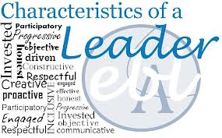

Sample Programme
 | Morning | Afternoon | evening
Sat 21st |  |  | Welcome. Name games  Getting to know each other on a personal level. Learning Buddy
Sun 22nd | Setting the scene  Getting to know each other better  Expectations (hopes and fears)  Guidelines for the training  Introduction Learning Log  Introduction to Youthpass and NFL.  Introduction to dissemination  Getting to know each other’s projects and motivations for this training and at the same time Introduction to surroundings | Getting ready for Learning, Leadership and Equality  Discussion of key-words  Finding common ground | Reflection time before dinner (individual and then share with your learning buddy)  Narratives of Leadership – storytelling!
Mon 23th | My values and Attitudes  How do values influence my life & which behaviour is connected to it. | The values of my surrounding – my working place, my family and how I deal with them  Value frame:  Human Rights leadership as a possible value base? | Reflection time before dinner this time in groups with mentor.  Leadership activity – led by the group!
Tue 24th | The world around me – understanding the different realities in the countries  Dealing with cultural diversity, gender & inclusion  mid-way evaluation | Free afternoon  Possibilities to visit some local heritage facilities incl. Tintern Abbey, Hook Lighthouse, Loftus Hall.  Or Wexford town | Evening out!
Wed 25th | Myself at the crossroad of leadership, gender, diversity & inclusion  Current Situation and future  Leadership skills to increase the mobility of unemployed/socially excluded young people | Resourcing myself 1:  Coaching conversation  Active Listening  Asking questions  Presentation from a life/ learning coach-  approach with 7 key-elements of coaching. | Movie night
Thur 26th | Resourcing myself 2:  Giving Feedback  Taking decisions  Activity on giving feedback including elements of Rosenberg’s theory of non-violent communication. The frame is working in trios and giving feedback in a work related situation. | Being agent of change  Finding new ways to deal with challenges in my own surrounding focusing on the topics of the training – leadership, diversity, inclusion & equality.  Using ‘Theatre of the Oppressed’ | reflection time with mentor) In group and alone. (before Dinner)  Open evening
Fri 27th | Taking action: Understanding myself & moving forward  How to be inclusive in your own environment  What to take home & what to leave  Partnership building in the Erasmus + programme | Youthpass  Dissemination of the training + making plans for when the participants return to their projects!  Evaluation | Last evening Party hosted by all the participants!
Sat | 28th Departure day

